Name: Julio Barros EID:E01963387

To Identify the System Profile
python2 vol.py -f ~/Desktop/MemoryDump_Lab1.raw imageinfo
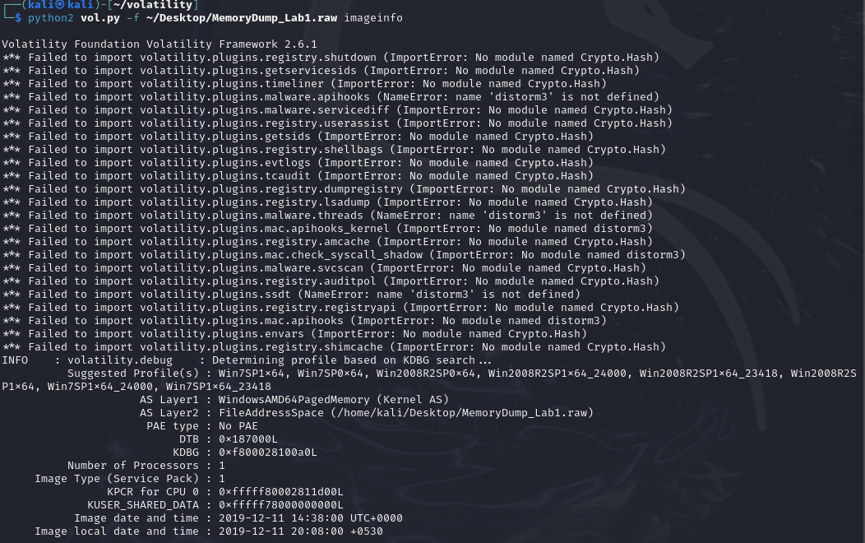
List Running Processes
python2 vol.py -f ~/Desktop/MemoryDump_Lab1.raw --profile=Win7SP1x64 pslist
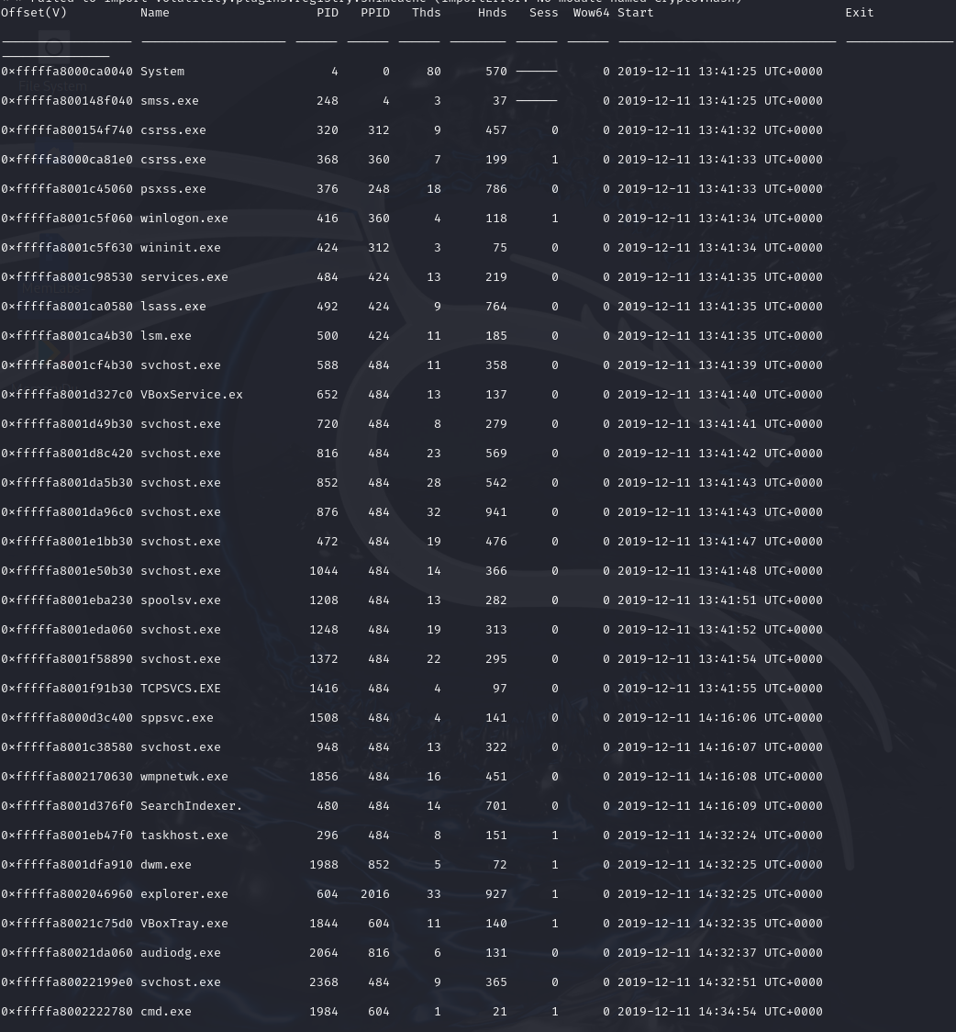
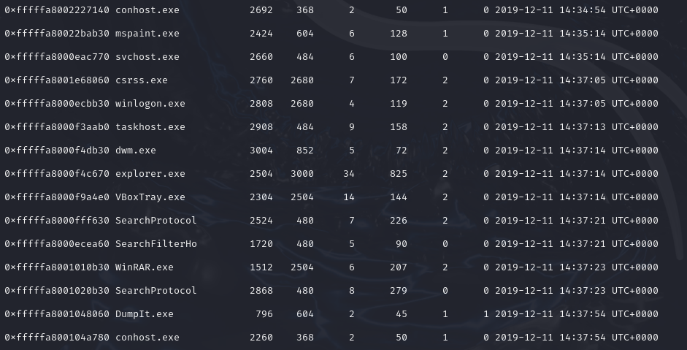
List Open Network Connections
python2 vol.py -f ~/Desktop/MemoryDump_Lab1.raw --profile=Win7SP1x64 netscan
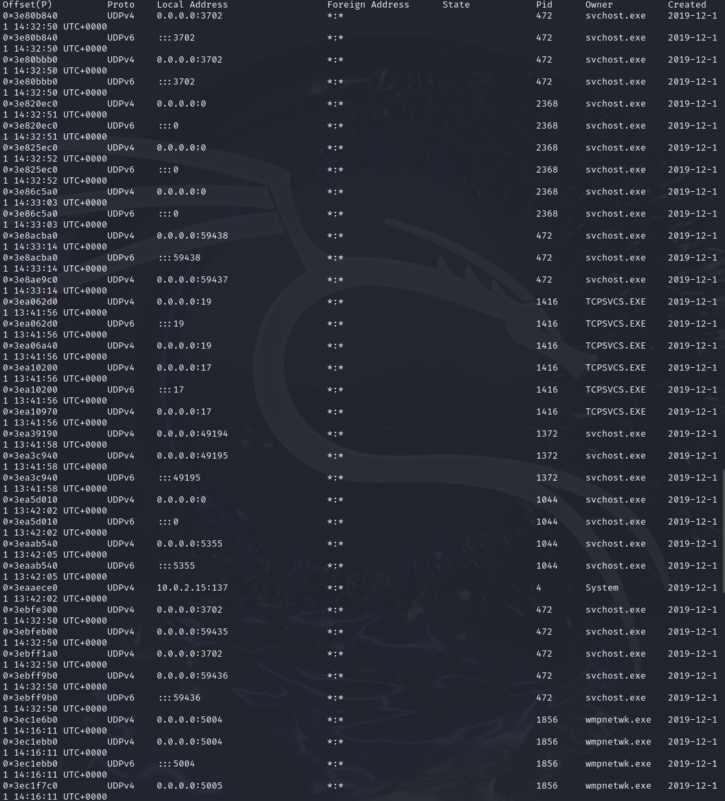
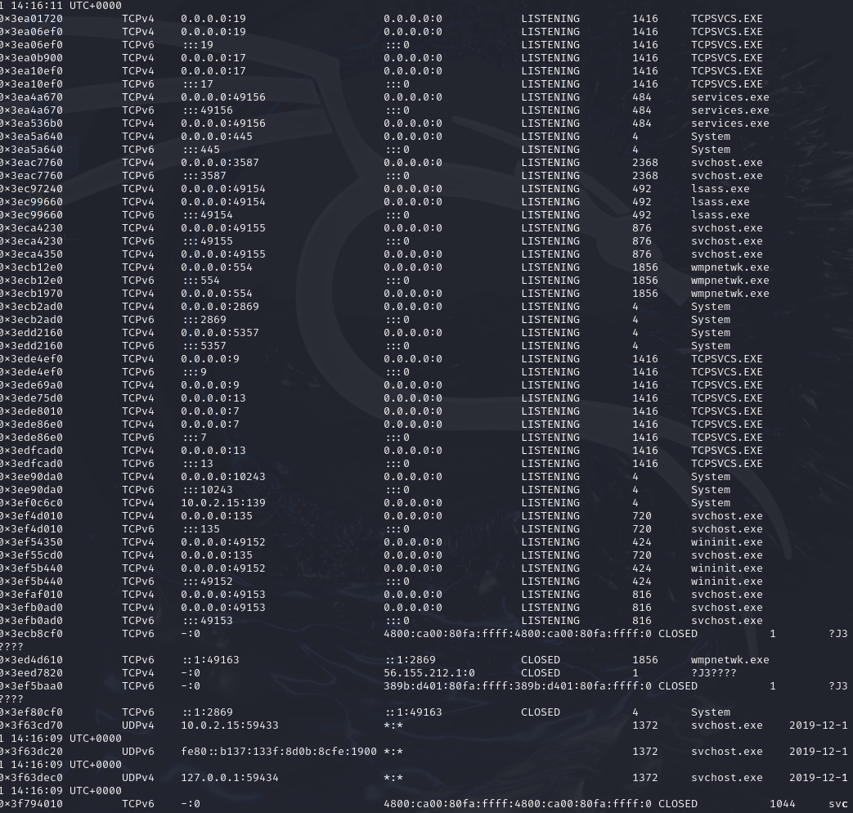
List Loaded DLLs for Each Process
python2 vol.py -f ~/Desktop/MemoryDump_Lab1.raw --profile=Win7SP1x64 dlllist
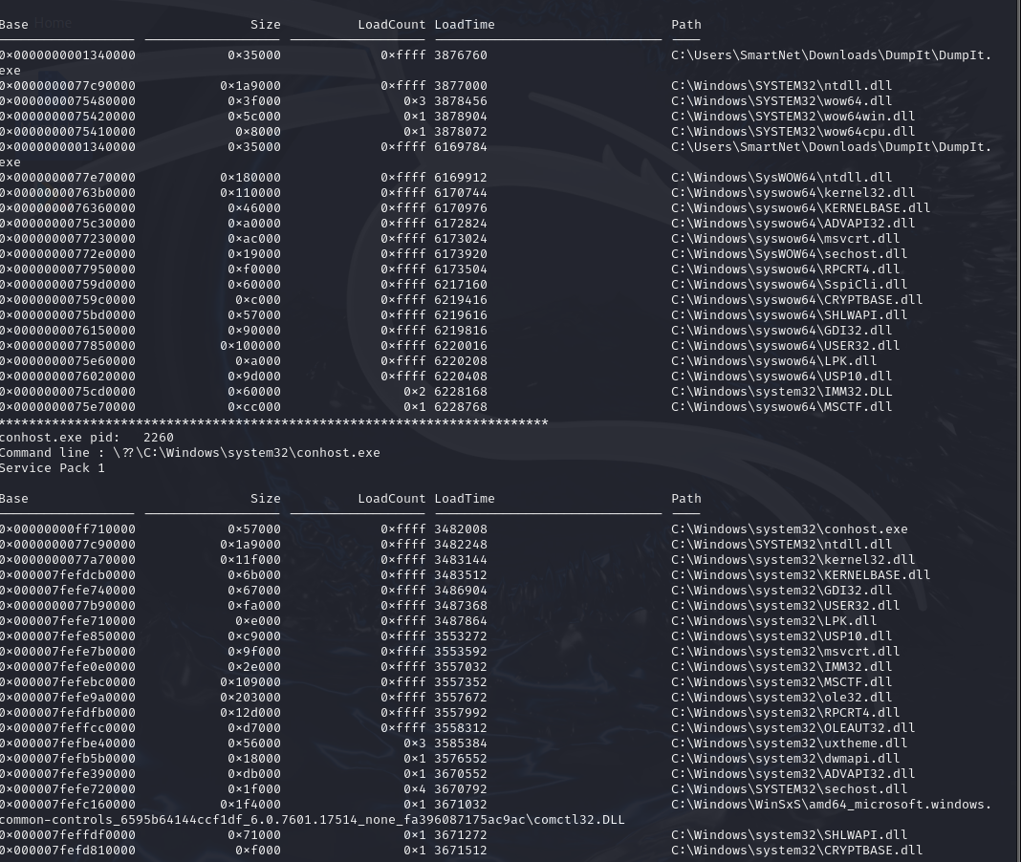
Scan for Open Files
python2 vol.py -f ~/Desktop/MemoryDump_Lab1.raw --profile=Win7SP1x64 filescan
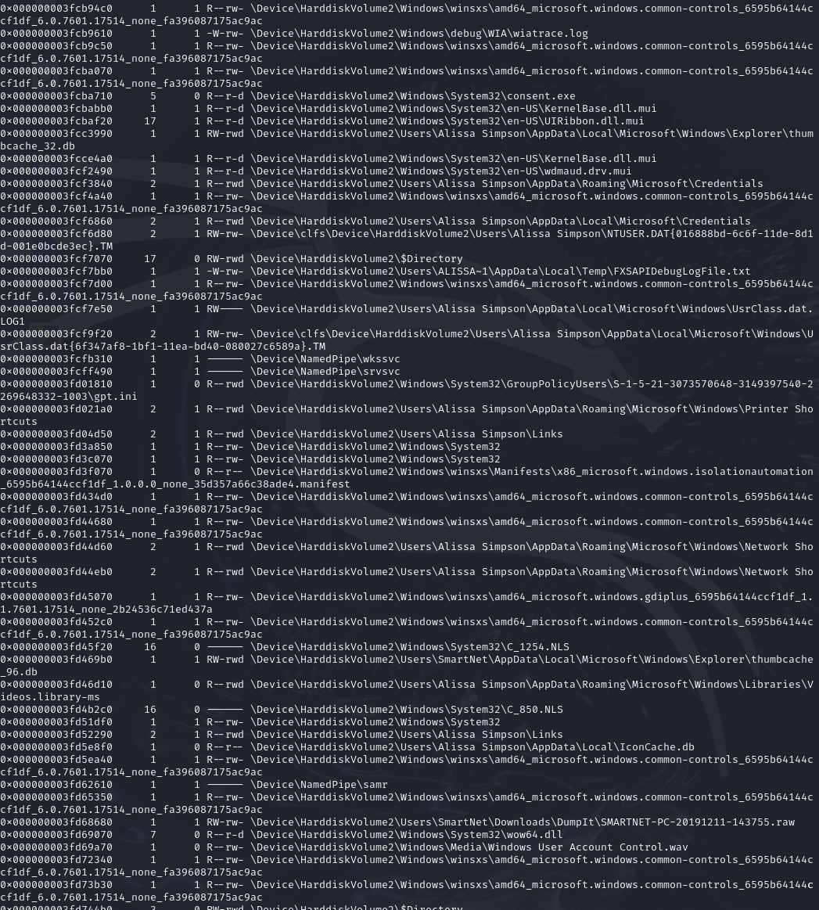
List User Sessions
python2 vol.py -f ~/Desktop/MemoryDump_Lab1.raw --profile=Win7SP1x64 sessions
